Table of Contents

Project: - Construction Cost Estimation and Bid Prediction 3
1.1 Introduction 3
1.2 Objective 3
1.3 Dataset Description 3
Fig # 1.3.1 Data Description 4
1.4 Data Mining and Exploration 4
1.5 Data preprocessing 5
Fig # 1.5.1 Encoding string 5
Fig # 1.5.2 Train and Test Split 6
1.6 Data visualization 6
Fig # 1.6.1 Import libraries 6
Fig # 1.6.2 scatter plot with feature(Builtup_Area) and target(cost) 7
Fig # 1.6.3 scatter Plot with best fit line 7
1.7 Model Development 7
1.8 Model Evaluation 8
Fig # 1.8.1 MAE,MSE,RMSE,R2 8
Fig # 1.8.2 Decision Tree 9
Fig # 1.8.3 Random Forest Regression 9
1.9Graphical representation all the features 9
Fig # 1.9.1 Random Forest Regression 10
1.10 Conclusion 10
Fig # 1.10.1 All model predictions result 11

Name of student: - Azhar Abbas
Course: - Artificial intelligence
Instructor: - Gulshan Yasmeen
Academy: - U-connect software center at Jutial Gilgit.
Date: - 29-10-2025

Project: - Construction Cost Estimation and Bid Prediction

1.1 Introduction
In the construction industry, estimating the total project cost before starting construction is a big challenge.
Many projects face budget over runs because the cost is not properly estimated at the early stage.
This project focuses on predicting the total construction cost using machine learning by analyzing different project features such as area, region, material index, labor rate, and design complexity.
The aim is to make the estimation process faster, more accurate, and data-driven to help engineers and contractors plan better.

1.2 Objective
- Apply machine learning techniques to predict the total cost of a construction project.
- Understand how different features affect the project cost.
- Build and compare regression models such as Linear Regression, Decision Tree, and Random Forest.
- Evaluate model performance and visualize results.
- Demonstrate the complete data science process from data collection to prediction.

1.3 Dataset Description
The dataset contains information about construction projects with the following features:
- Area_sqft: Covered building area per sqrft.
- Floors: Number of floors.
- Material_Quality: Indicates the quality of materials.
- Location _Type: Type of location — Urban, SubUrban, or Rural.
- Labor_cost_per_Sqrft : Average labor cost per sqrft.
- Material_cost_per_Sqrft: indicate the material cost with per sqrft
- Design_Complexity): Complexity level of the project design.
- Duration _months: Estimated completion time.
- Total_Cost (PKR): Target variable — total project cost.
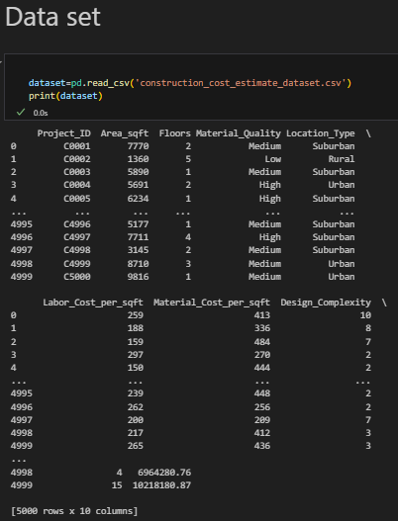

Fig # 1.3.1 Data Description
The dataset includes around 5000 records and was prepared to reflect real-world construction conditions

1.4 Data Mining and Exploration
In this stage, the dataset was explored to understand its structure, size, and main characteristics.
Data mining helped identify patterns and relationships between project features and the final cost.
Key Findings:
- Projects in Urban areas have the highest costs due to expensive labor and materials.
- SubUrban areas show medium costs.
- Rural areas have the lowest costs because of simpler designs and cheaper labor.
- Larger Area_sqft , higher Material_quality and Design_Complexity lead to increased costs.
- Exploratory analysis helped in identifying data trends, checking missing values, and preparing for data cleaning and visualization

1.5 Data preprocessing
Data preprocessing ensured the dataset was clean and suitable for model training.
Steps performed:
- Missing Values: Checked and filled missing entries with mean or median values.
- Duplicate Removal: Removed duplicate records to avoid bias.
- Outlier Handling: Examined and corrected extreme values in cost and area.
- Encoding: Converted categorical variables like material_Quality and Location_Type (Urban, subUrban, Rural) into numeric form using one-hot encoding. (fig #1.5.1)
- Scaling: Standardized numerical features such as Area_Sqrft, Material_Quality, and Labor_cost for uniformity.
- Data Splitting: Divided data into 80% training and 20% testing sets to evaluate model performance properly. (fig #1.5.2)
This preprocessing step helped improve the accuracy and reliability of the models.

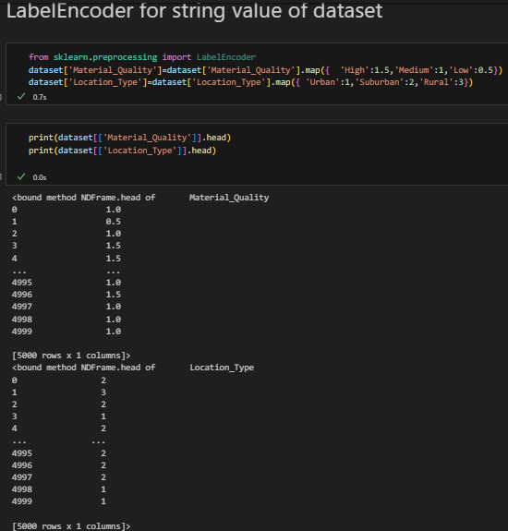

Fig # 1.5.1 Encoding string

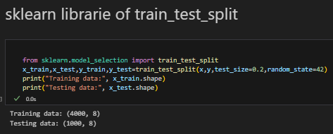

Fig # 1.5.2 Train and Test Split

1.6 Data visualization
Data visualization was used to understand feature distributions and relationships.
Various plots were created using Matplotlib and Seaborn libraries.
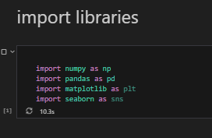

Fig # 1.6.1 Import libraries
Key Visualizations:
- Histograms: Showed distribution of numerical features like Area_sqft and Total_Cost.
Boxplots: Helped detect outliers and compared costs across different regions.
- Scatter Plots: Displayed relationships between Area_sqft and Total_Cost showing a positive trend.
- Correlation Heatmap: Identified strong positive relationships between Area_sqft, Material_Quality, Labor_cost_per_Sqrft, and Cost.
These visualizations made it easier to understand the data and supported feature selection for the model.
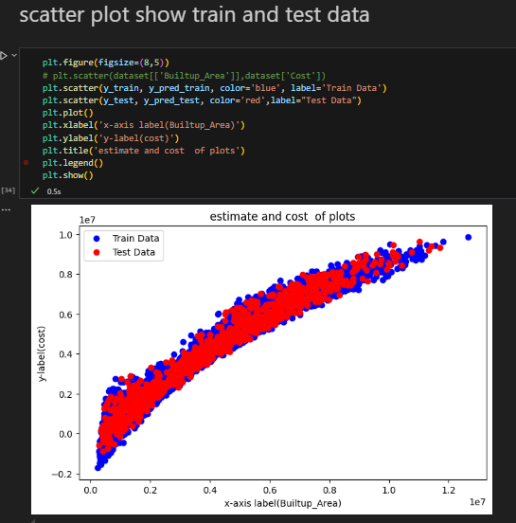

Fig # 1.6.2 scatter plot with feature(Builtup_Area) and target(cost)
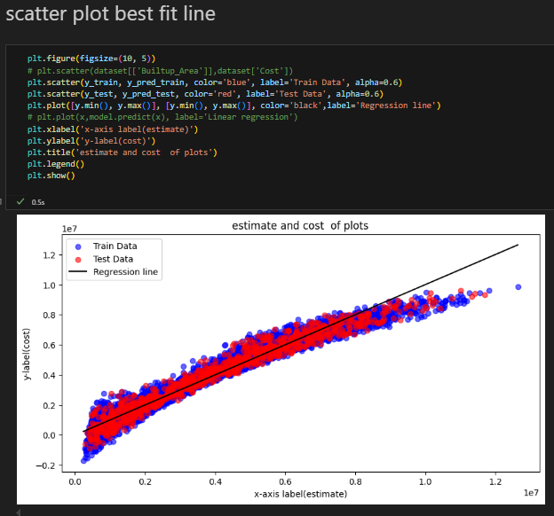

Fig # 1.6.3 scatter Plot with best fit line

1.7 Model Development
There are two type of machine learning technique were applied
- Supervised learning (Regression)
The goal was to predict a continuous target variable — project cost.
Models used:
- Linear Regression: To capture linear relationships between features and cost.
- Decision Tree Regressor: To handle non-linear relationships.
- Random Forest Regressor: Used for better accuracy and stability by combining multiple decision trees. Among them, Random Forest gave the most accurate and consistent predictions

1.8 Model Evaluation
The models were evaluated using performance metrics suitable for regression and clustering.
- Linear Regression model
- R² Score: Measured how well the model explains cost variation.
- MAE (Mean Absolute Error): Average error between predicted and actual costs.
- RMSE (Root Mean Square Error): Measured accuracy and penalized large errors.
Results:
- The Linear Regression model gave a good baseline performance.
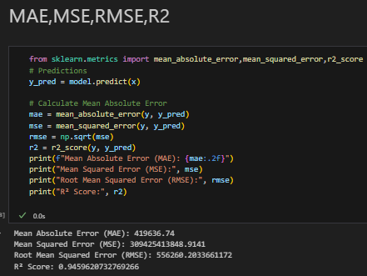

Fig # 1.8.1 MAE,MSE,RMSE,R2
- The Decision Tree improved results of training data good. 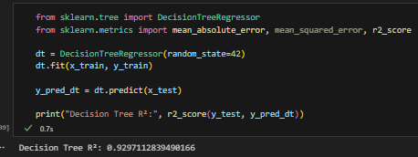

Fig # 1.8.2 Decision Tree
- The Random Forest Regressor performed the best with the highest R², showing reliable and accurate predictions. 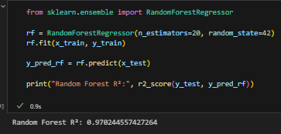

Fig # 1.8.3 Random Forest Regression
Interpretation:
The results show that Builtup_Area, Material_Index, Labor_Rate, and Design_Complexity are the major factors affecting total project cost.
This model can be a helpful tool for engineers and contractors to estimate cost early and prepare realistic project bids.

1.9Graphical representation all the features
The Graphical representation feature of all the Data set are: -
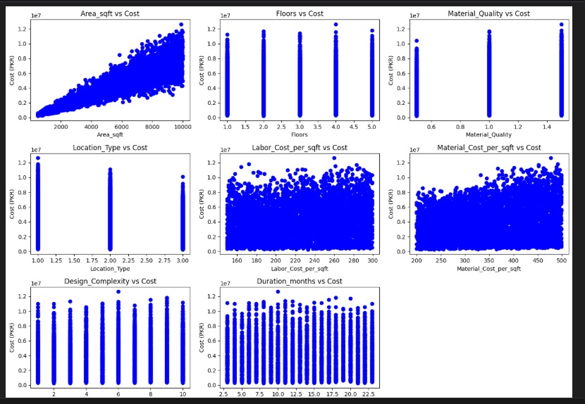

Fig # 1.9.1 Random Forest Regression

1.10 Conclusion
This project successfully applied the complete data science and machine learning process to a real-world problem.
From data collection and preprocessing to visualization, model training, and evaluation — every stage was completed to understand and predict construction costs effectively.
The final Random Forest model provided the most accurate cost predictions.
The project demonstrated key concepts such as data mining, data cleaning, feature analysis, supervised learning, and model evaluation.
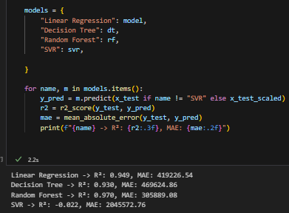

Fig # 1.10.1 All model predict results

Future work
- Integrate the model into a web-based app for live cost predictions.
- Add more features such as land price, material brand, and city-level data.
- Use advanced models like Neural Networks for even better results.

